AI Assistant Coding
Assignment-9.3

Name: V. Sai Anand
Roll No: 2303a51310
Batch:05

Task 1: Basic Docstring Generation
Scenario: You are developing a utility function that processes numerical lists and must be properly documented for future maintenance.
Prompt:
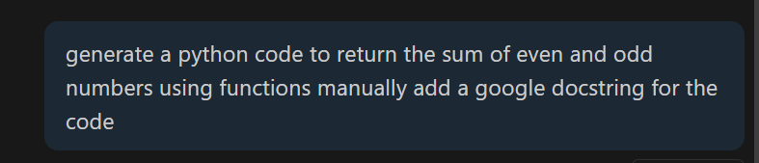
Code
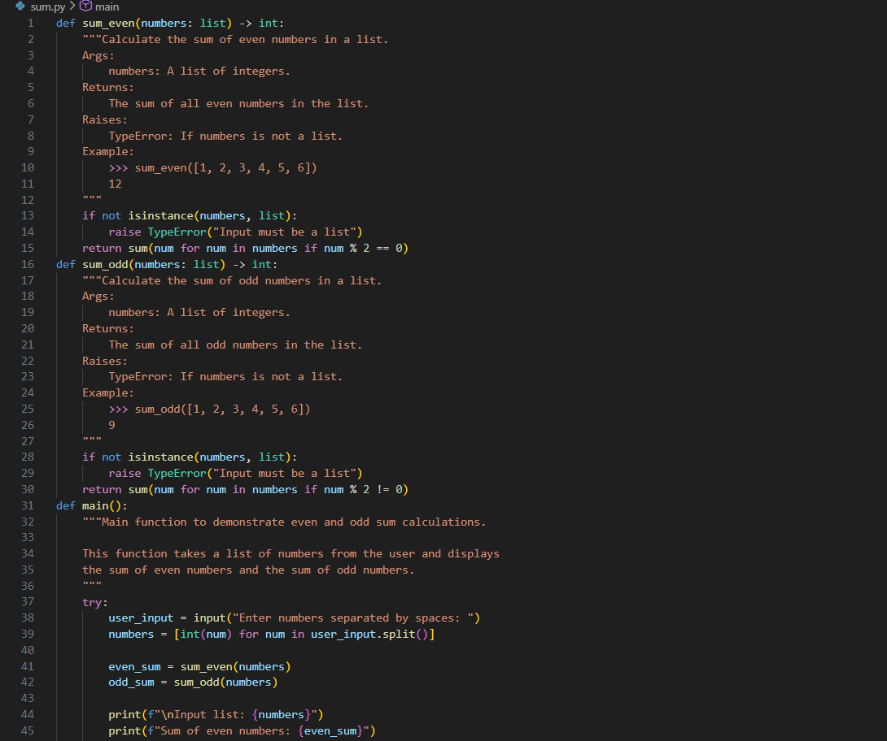
Output:
• Compare the AI-generated docstring with the manually written docstring
Key sections:
- Manual vs AI-Generated Documentation - Overview of both approaches
- Characteristics - What makes each approach unique
- Google Docstring Structure - Detailed breakdown of each section (Args, Returns, Raises, Examples)
- Benefits of AI-Generated Docs - Developer, code quality, and maintenance advantages
- Side-by-side Examples - Practical comparison from your sum.py code
- Best Practices - Hybrid approach combining both manual and AI methods

The document shows how your AI-generated Google docstrings are:
- Consistent and standardized
- Complete with type info, exceptions, and examples
- IDE-integrated for better development experience
- Maintainable and searchable.
Task 2: Automatic Inline Comments
Scenario
You are developing a student management module that must be easy to understand for new developers.
Prompt:
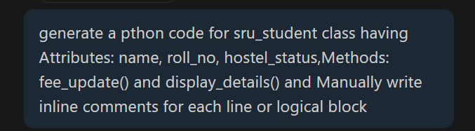
Code:
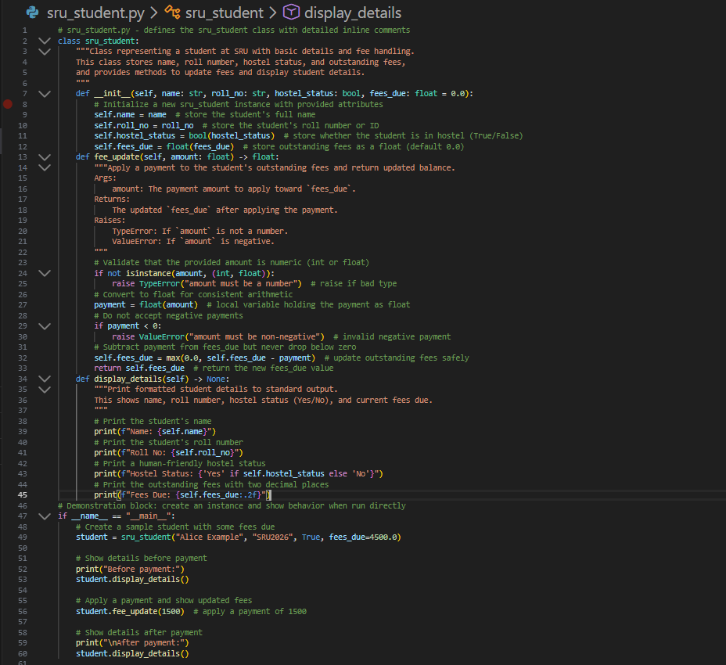
Output:
Comparative Analysis
Purpose & Focus:
  - Manual: explains developer intent and business reasoning.
  - AI: describes code behavior, syntax, and structure.
Consistency:
  - Manual: varies by author.
  - AI: uniform style across the codebase.
Completeness:
  - Manual: often partial or missing.
  - AI: systematically includes Args/Returns/Examples.
Speed:
  - Manual: slow and effort-intensive.
  - AI: fast and scalable.
Accuracy:
  - Manual: high for intent.
  - AI: good for obvious logic, may miss corner cases.
Strengths of AI Comments
  - Rapid generation at scale
  - Standardized documentation format
  - Good use of type hints
  - Helps junior developers
  - Easy CI/CD automation
Limitations of AI Comments
  - Misses “why” and business context
  - Lacks domain knowledge
  - Risk of incorrect interpretations
  - Can become outdated
  - Over-verbose/redundant
  - May expose sensitive details
  - Lacks human tone and ownership.
Task 3: Module-Level and Function-Level Documentation
ScenarioYou are building a small calculator module that will be shared across multiple projects and
requires structured documentation.
Prompt:

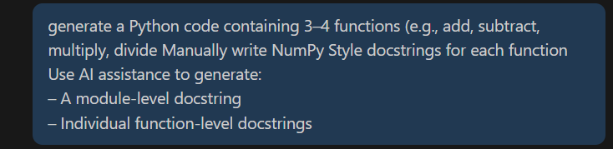
Code:
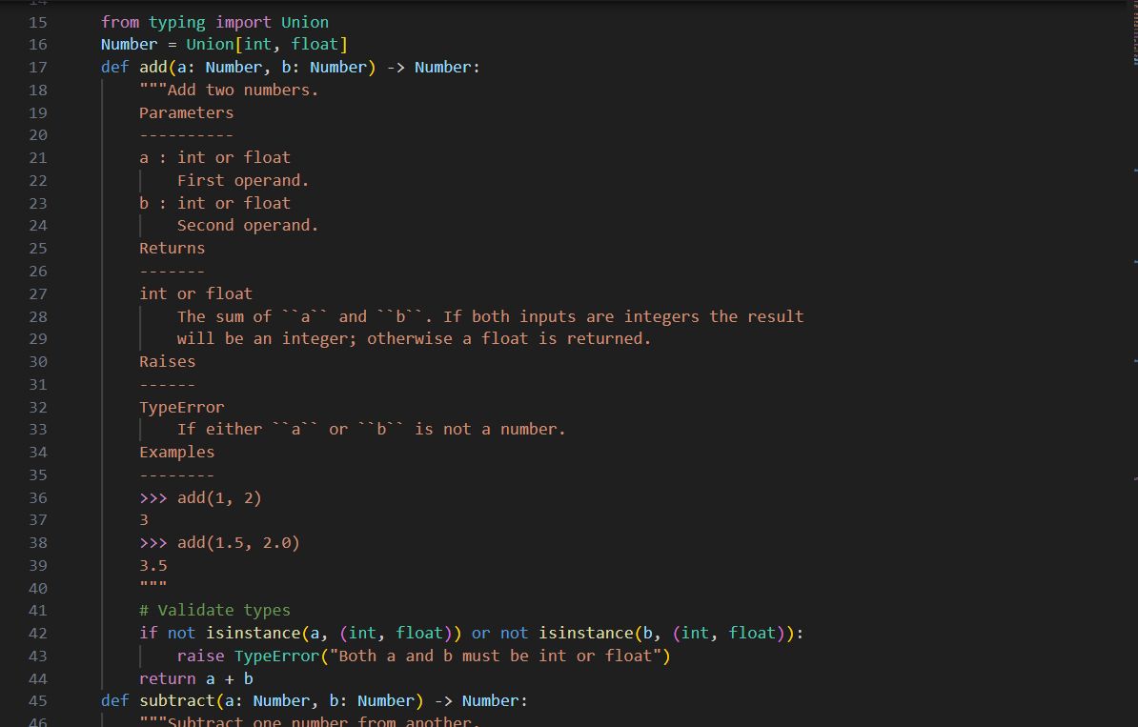
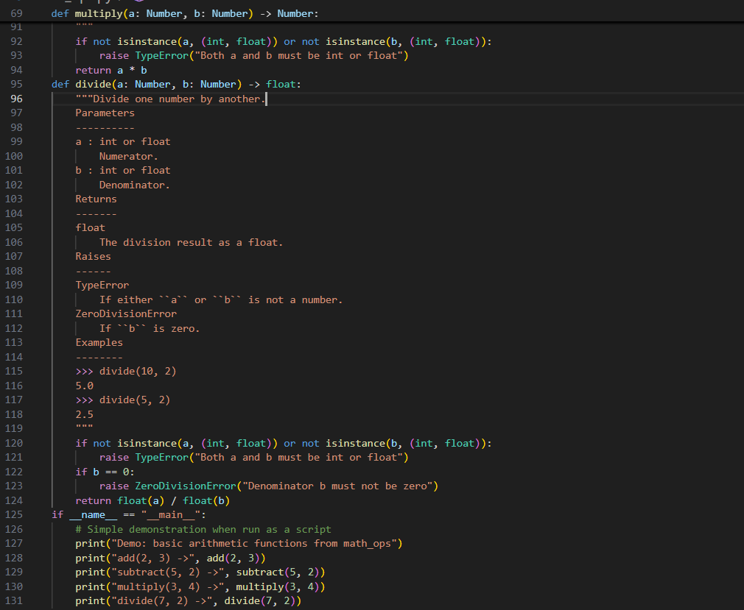

Output:
Comparison between AI-generated docstrings with manually written ones
- Purpose: AI—produce structured docs quickly;
Manual—explain intent, rationale, domain nuance.
- Speed:
AI—instant and scalable; Manual—time-consuming.
- Consistency:
AI—uniform format; Manual—varies by author.
- Completeness:
AI—reliable sections (Args/Returns/Examples); Manual—often incomplete.
- Accuracy:
Manual—better for intent/edge cases; AI—good for surface logic, may misread intent.
- Context:
Manual—aware of history and business rules; AI—limited without prompts.
- Maintainability:
AI—easy to regenerate but can go stale; Manual—accurate if maintained, often neglected.
- Tone & Readability:
AI—neutral and predictable; Manual—team voice with caveats.
- Granularity:
AI—mechanics and types; Manual—“why,” pitfalls, alternatives.
- Risk:
AI—trivial or incorrect details, oversharing; Manual—inconsistency or missing docs.

